WEEK 8: CREATE STORYBOARDS TO REPRESENT THE USER FLOW FOR A MOBILE APP (E.G., FOOD DELIVERY APP) USING BALSAMIQ
V Roshini | 230701270 | CSE-FC
AIM: Create storyboards to represent the user flow for a mobile app (e.g., food delivery app) using Balsamiq.

Page 1: Home Screen
- This is the landing page where the user can browse or search for nearby restaurants.
- It includes a search bar, featured restaurant banners, and category buttons (e.g., Pizza, Burgers, Chinese).
- The main user action here is selecting a restaurant to view its menu.
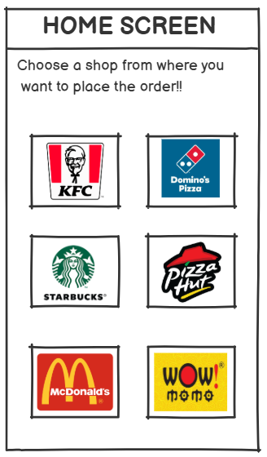
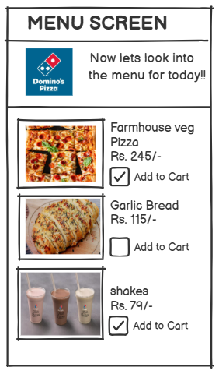

Page 2: Menu Screen
- After selecting a restaurant, the user sees the menu page.
- It shows a list of available food items, each with a description, price, and “Add to Cart” button.
- The user can browse, select items, and add them to their cart.

Page 3: Cart Screen
- This screen displays the user’s selected items, with quantities, prices, and an option to remove or edit the cart.
- It also shows the total cost and a prominent “Proceed to Checkout” button.
- The main goal here is for the user to review their order before moving forward.

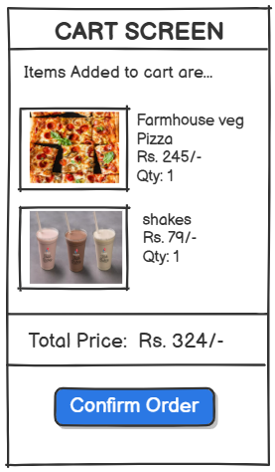

Page 4: Checkout Screen
- On the checkout page, the user enters delivery details, selects the payment method, and reviews the final order summary.
- Important elements include address fields, payment options (e.g., card, wallet), and a “Place Order” button.

Page 5: Order Confirmation Screen
- Once the order is placed, the confirmation screen provides a summary, including estimated delivery time, order number, and a thank-you message.
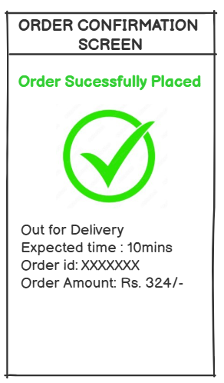
- This is the final touchpoint, reassuring the user that their order is being processed.
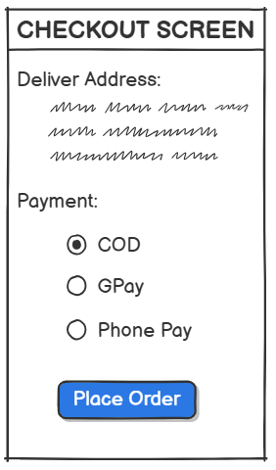
The storyboard captures a linear user journey:
Home → Menu → Cart → Checkout → Confirmation.

